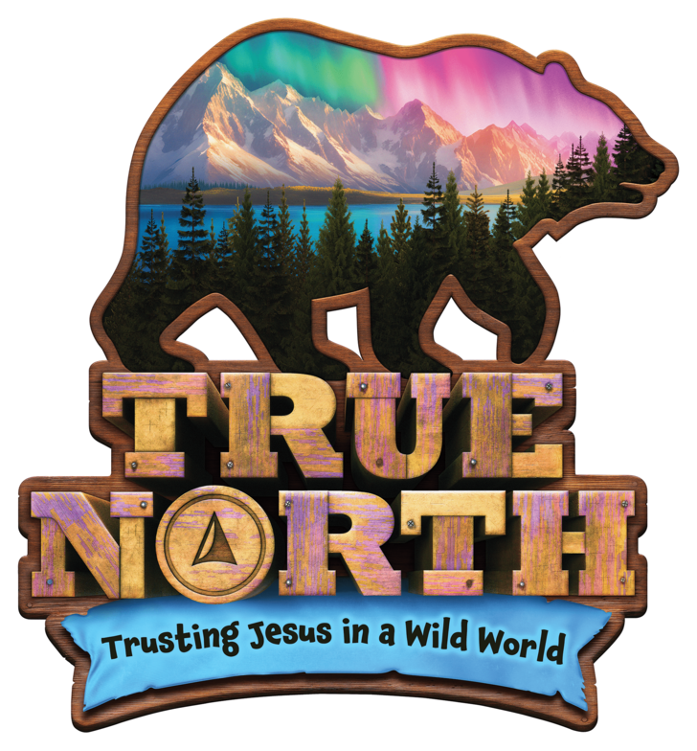

Jesus is everywhere!

We have become a VBS sharing community! Sharing our time, talents, resources and love of Christ to bring God’s message into the world!

If you can’t make our church’s VBS or you just can’t get enough of the fun, here are some other locations that you might want to visit

Faith Lutheran Church (Sykesville) June 23rd-27th

Covenant of Grace (Reisterstown) July 7th-11th

Holy Spirit Lutheran Church (Sykesville) July 21st-25th

Freedom Church (Old Liberty RD west) August 4th-8th

Register for our VBS right here